1. **Model 1**
   1. Accuracy: Around 97.1%

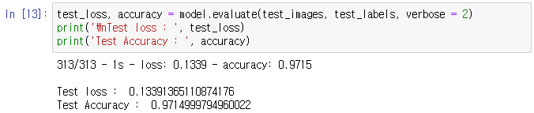

* 1. Success cases

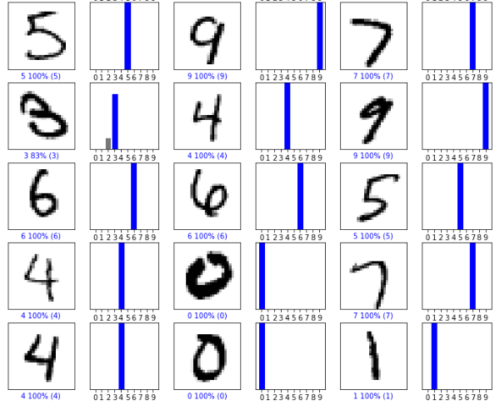

* 1. Failure cases

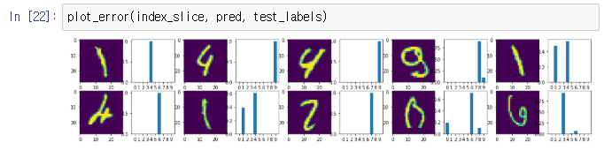

1. **Model 2**
   1. Accuracy: Around 98.8%

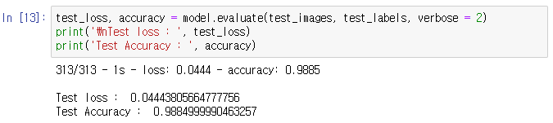

* 1. Success cases

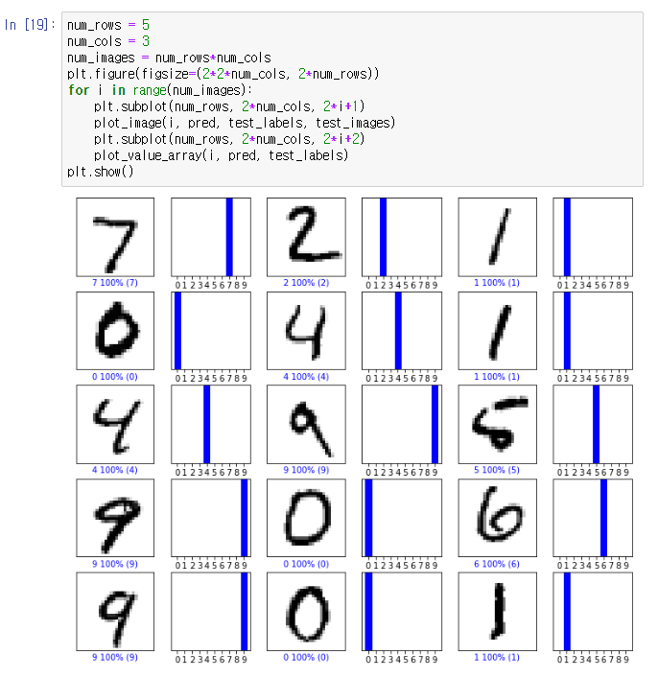

* 1. Failure cases

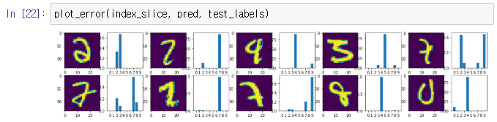

1. **Model 3**
   1. Accuracy: Around 98.8%

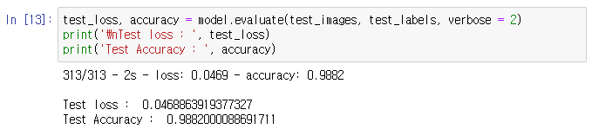

* 1. Success cases

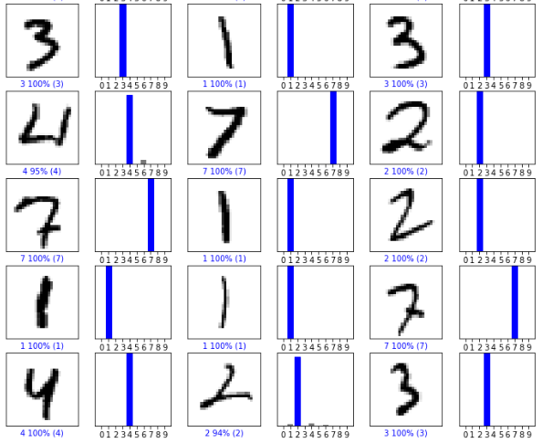

* 1. Failure cases

